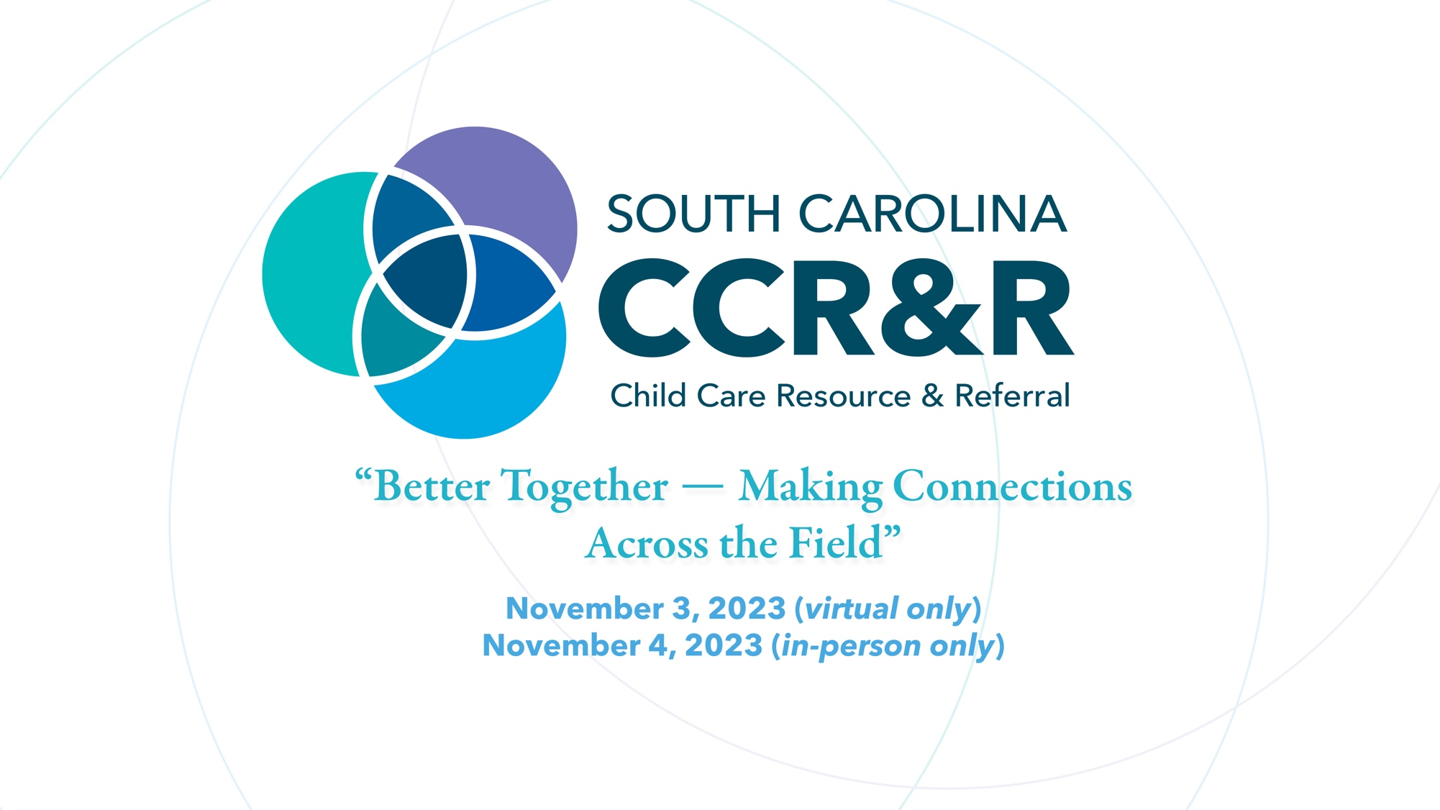
Family Child Care Conference, "Better Together — Making Connections Across the Field."
Friday, November 3rd – Saturday & November 4th 2023
Friday, November 3rd – Virtual
9:15AM-10:45AM, 1.5 credits

Emily Durham, PSSA: Understanding Early Intervention in South Carolina

You have identified a child in your classroom or center who is demonstrating developmental delays. You’ve worked with the teachers, you’ve spoken to the parents, and you’ve tried all different techniques, but the child is still struggling. What do you do? The professional development session will introduce early childhood educators to the early intervention assessment process and the services available to children with special needs.

9:15AM-10:45AM, 1.5 credits

Darlene Faucette: Increase Parent Referrals to Your Program and Improve Your Business Flow

Connecting to SC Child Care Resource and Referral Parent referral System through SC Endeavors profile is an easy way to market your program. This session will walk you through the technology of SC Endeavors. You learn about features, reports, Pathways to Quality, and how to Market services with SC CCR&R. This is an exciting way to learn about features in SC Endeavors you did not know about that can support your program quality and services. Join us to learn more about free service for you in our state.

11:00AM-12:00PM , 1 credit

Whitney Brown, I-HOPE: KEYNOTE: Having A Business Plan

Do you have dreams of being a small business owner? A great idea that solves a problem? We can help you turn your idea into a profitable business giving you the ability to support your family and impact our community. Come and learn how to build a business plan with us.

12:15PM-1:45PM, 1.5 credits

Cynthia Lara, Licensing: Child Care Licensing Family Child Care Homes 2023 Proposed Regulations

The training will introduce the Proposed Family Child Care Homes (FCCH) 2023 Regulations to providers who operate an FCCH. It will provide insight into the recommendations to improve health and safety measures to safeguard children served.

2:00PM-3:30PM, 1.5 credits

Melissa Outen, Licensing: Health and Safety

Do want to know what's happening in Family Child Care? Get informed. This session will discuss and identify what providers need to know as it relates to the Licensing Laws and Regulation.

3:45PM-4:45PM, 1 credit

Rebecca Crenshaw, Endeavors: Career Ladder

Take the next step – apply for your career ladder level today! Have you signed into the registry system? Received your annual training hours and downloaded your learning record? The SC Endeavors Registry is ready to process applications for all. Obtaining your career ladder level allows you to showcase your educational level, as well as providing you with a pathway to achieve even more. Learn how to apply, and how YOU can obtain a $150 bonus!

3:45PM-4:45PM, 1 credit

Jenny Ricks, ABC Quality: What's in the Lunchbox

Make informed choices about the foods served in childcare! Lunchtime is an opportunity for children to grow healthy through a variety of foods and beverages. In this session, we will identify nutritious foods and best practices for child nutrition and review the health benefits of a well-rounded diet for children.

3:45PM-4:45PM, 1 credit

Monica Akers-Bellamy, Teneshia Slempa and Heather Reyes: FCC Network Introduction

Please join the Family Child Care Quality Coaches for a peek into the upcoming SC CCR&R Family Child Care Network! The FCC Network will be an amazing, free opportunity to gain training credits, connect with other FCCH providers in the State, and gain valuable resources for moving your business forward. Find out how you can become a part of it!

3:45PM-4:45PM, 1 credit

Jessica Sharp, PITC: Safe Sleep

This session will guide participants through the guidelines and the “ABCs” of Safe Sleep. After this session, participants will be able to describe the importance of using safe sleep practices in child care to keep infants healthy and safe.

Saturday, November 4th – In Person
9:15AM-10:45AM, 1.5 credits, Room 109 (30 seats)

Erin Martin, SCIC: Build a Bridge to Inclusion in Family Child Care

This session will define the concept “inclusion,” discuss the benefits of promoting an inclusive environment, examine the types of inclusion support, and explore ways inclusion can be successful in Family Child Care.

9:15AM-10:45AM, 1.5 credits, Room 204 (30 seats)

Stephanie McAvoy and Marsha Whack, Pyramid PIECES: Reframing Adult Behavior to Promote Positive Social Emotional Development in Young Children

This session will define challenging behaviors and how to identify our own hot buttons, understand the function of challenging behaviors, and gain preventative strategies from The 5 Classroom-wide Practices to Improve Behavior.
Providers will leave this session feeling like they have the support to challenge and reframe their approach to improving challenging behaviors. Co-presenter Marsha Whack, Family Childcare Owner and Provider, has utilized the Behavior Support Network Services, learning that “the hardest part of change is trusting the process.”

9:15AM-10:45AM, 1.5 credits, Room 105 Auditorium

Jenn Adams, SC CCR&R: The Guiding Principles of Behavior

During this session staff will be introduced to strategies that support children’s Emotional and Social Development using the SC Early Learning Standards. They will learn how to use these strategies to promote positive guidance methods in the classroom.

9:15AM-10:45AM, 1.5 credits, Room 202 (24 seats)

Cliff Adams: Record Keeping for Child Care Providers

Allow a seasoned tax professional help you learn the importance of good record keeping and what records should be kept for your business’s needs.

11:00AM-12:00PM, 1 credit, Room 105 Auditorium

Ruth Buckmire, His Daycare: KEYNOTE

Ruth’s description: During the keynote session, Ruth Buckmire will share her incredible journey in the early care and education field. She will share her start as a family child care provider. She will also share her educational journey with T.E.A.C.H. scholarships through SC Endeavors. She is now a center-based early care and education program owner and received the honor of Greenville County Chamber of Commerce’s 2023 Women-Owned Business Award. Ruth's keynote includes tips on setting up a family child care business, legal and regulatory requirements, and the physical aspects of setting up a home space. There will be time for question and answer.

Lunch: 12:00PM-1:00PM
1:00PM-3:00PM, 2 credits, Room 105 Auditorium

Monica Akers-Bellamy & Jenn Adams: Best Practices for Family Child Care Homes

Join us to learn the top 5 mistakes family child care providers make and how to avoid them.

1:00PM-2:00PM, 1 credit, Room 109 (30 seats)

Sherry Ly Ching Chen King and Tresa Nelson - Module I. Budgets, Projections, and Planning for Center-Based Child Care Providers

The purpose of this training is to strengthen child care providers’ foundational knowledge of fiscal terms, concepts, and practices. It encourages providers to realize the importance of financial planning to the sustainability of their business operations. It provides tips and best practices to help break down fiscal processes into manageable steps.

1:00PM-2:00PM, 1 credit, Room 217 (30 seats)
Shelley Summer, PSSA: What is PSSA?

Operations director Shelley Summer introduces family providers to the many resources that Palmetto Shared Services Alliance has to offer, including downloadable content, professional development opportunities, and ongoing assistance with your child care business!

1:00PM-2:00PM, 1 credit, Room 218 (30 seats)
Darlene Faucette, SC CCR&R: Playing and Teaching with Loose Parts

Join this session and discover the excitement of loose parts play activities that give children the opportunity to express creativity by using materials that can be manipulated, transformed, and created through play activities. Teachers will learn how these activities connect to the SC Early Learning Standards and ABC Process Quality Guide

2:15PM-3:15PM, 1 credit, Room 217 (30 seats)

Teneshia Slempa and Melissa McDonald- SC CCR&R Employee: FCC Network Introduction

Please join the Family Child Care Quality Coaches for a peek into the upcoming SC CCR&R Family Child Care Network! The FCC Network will be an amazing, free opportunity to gain training credits, connect with other FCCH providers in the State, and gain valuable resources for moving your business forward. Find out how you can become a part of it!

2:15PM-3:15PM, 1 credit, Room 218 (30 seats)

Linda Caraway-Doherty, SC CCR&R: Project Learning Tree Conference Teaser

Join us for this session to learn great ways to get the Tree's and Me Curriculum for your classroom for free from Project Learning Tree (PLT). Learn how it will increase nature-based learning with children from birth through age 5. This program will connect you to the curriculum and its connection to the SC Early Learning standards for lesson planning. The nature-based learning activities children learn will build stewardship of our environment. Come learn about this program with us

2:15PM-3:15PM, 1 credit, Room 109 (30 seats)

Sherry Ly Ching Chen King and Tresa Nelson Part 2 - Module I. Budgets, Projections, and Planning for Center-Based Child Care Providers

The purpose of this training is to strengthen child care providers’ foundational knowledge of fiscal terms, concepts, and practices. It encourages providers to realize the importance of financial planning to the sustainability of their business operations. It provides tips and best practices to help break down fiscal processes into manageable steps.

2:15PM-3:15PM, 1 credit, Room 204 (30 seats)

Joy Huyck: Welcoming Dual Language Learners

Participants will learn how language development for Dual Language Learners progresses, how it compares to monolingual students, social development impacts and how to implement strategies that support DLLs in the classroom.
Access the speaker’s bios here!

